Punch Out Instructions

NOTE: These instructions display information for School Specialty, but these apply to any and all vendors that Punch Out is set up for. It is possible, however that the ordering steps within a vendor’s website may vary.

- Access to Punch-Out can be found from both the Purchasing and Schools/Departments dashboards of BusinessPlus: PunchOut Web Shopping – POUPPP
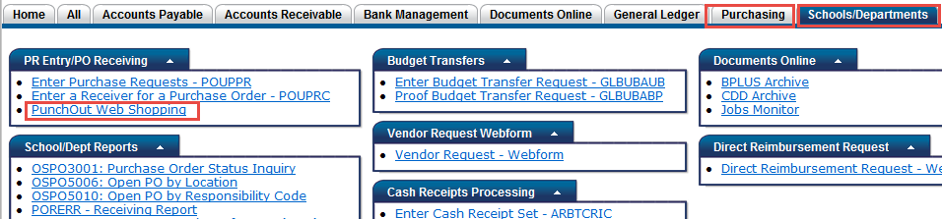
- Enter the account number and Ship To location. You will have to know the full account number as there is not an account number look up like there is with a Purchase Request (PR).

- Click on the Shop link.

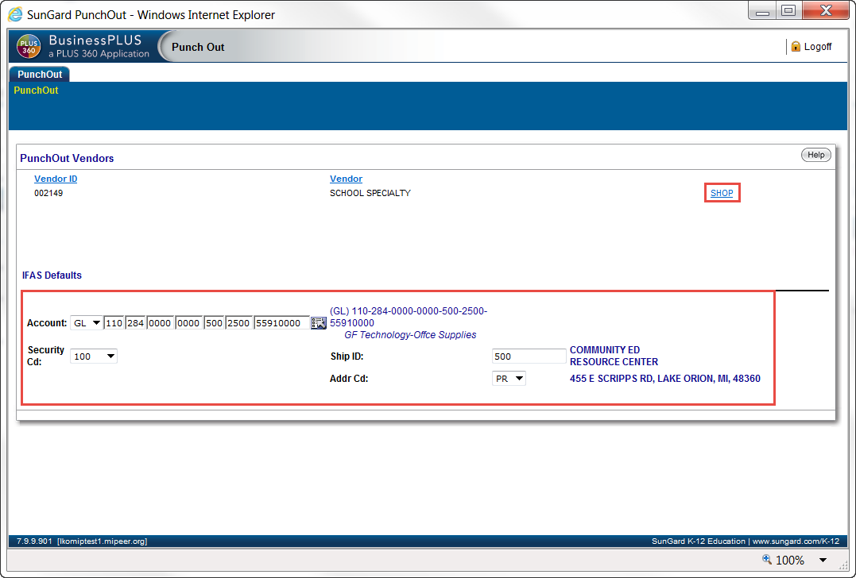

User will be taken directly to the School Specialty’s website to shop.

- User shops, as usual, by selecting the items needed and Adds them to their Cart.

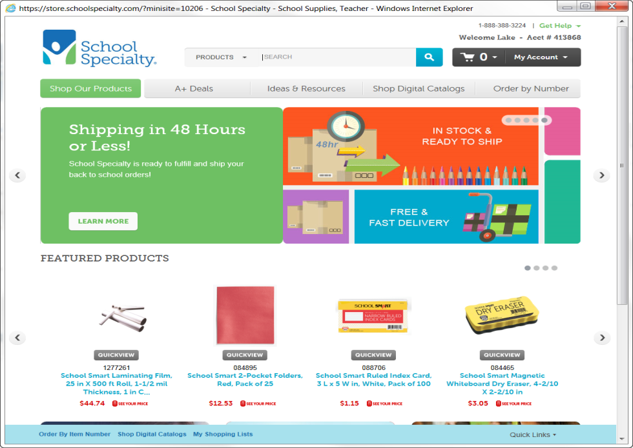

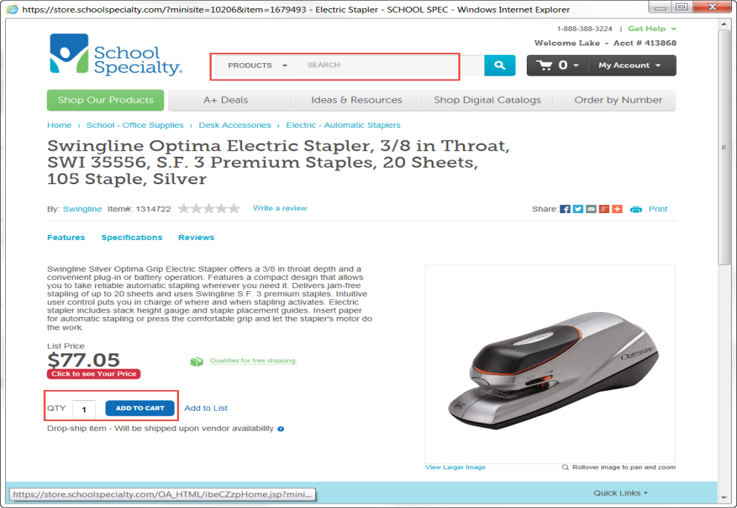

- Click on View Cart/Checkout
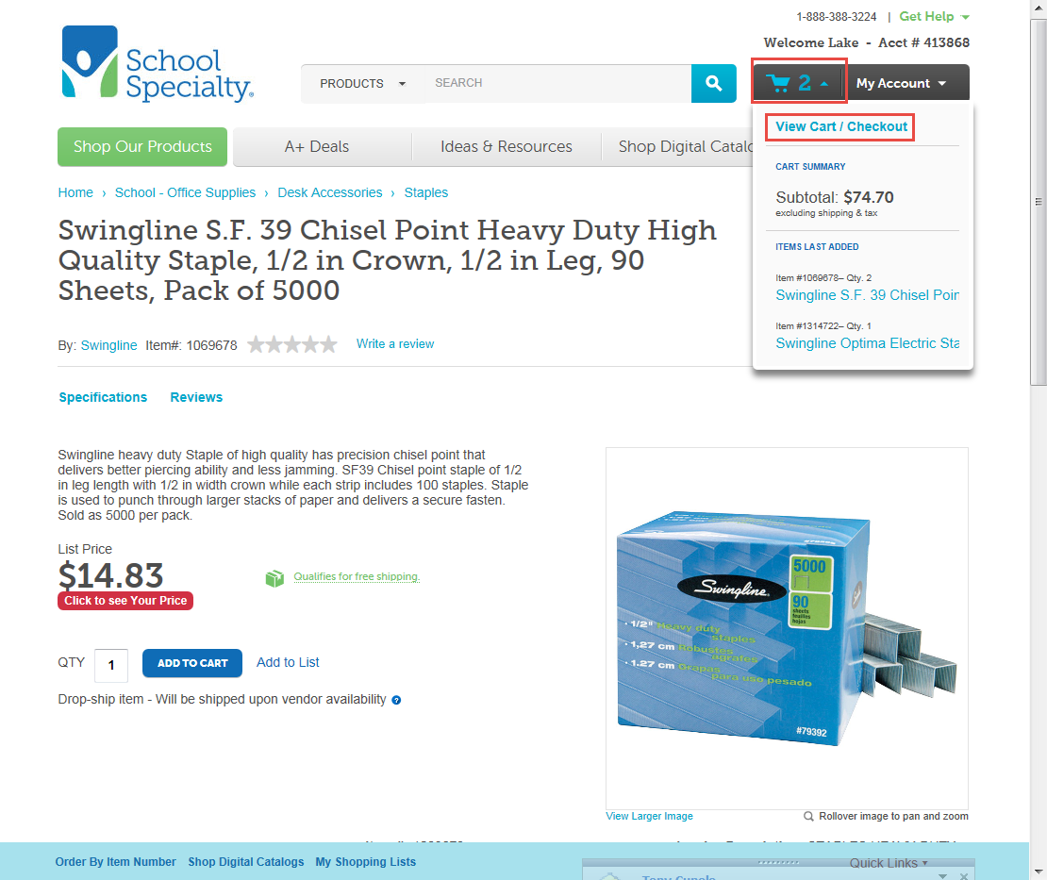

- Click on Proceed to Checkout
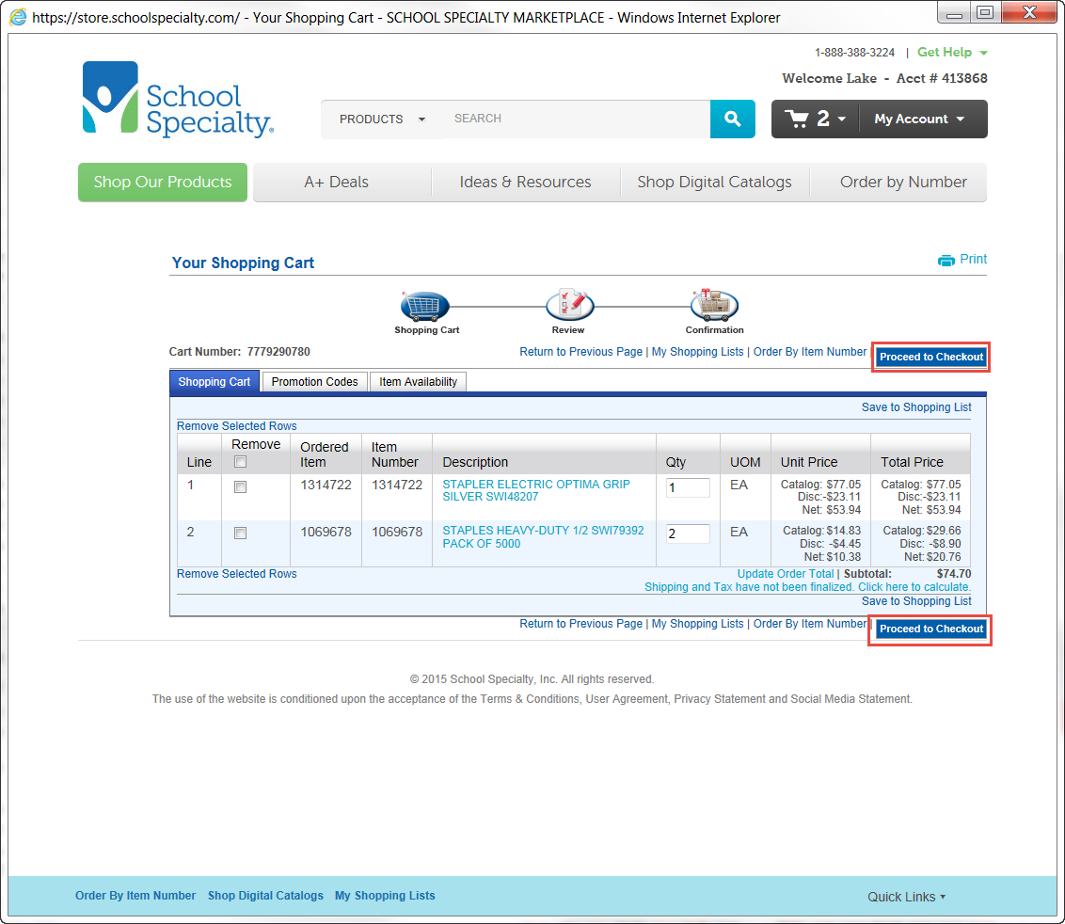

- Click on Submit
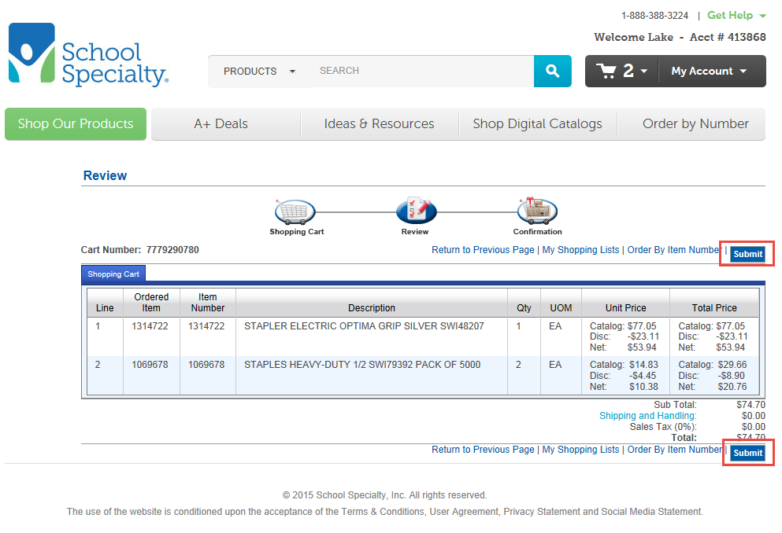

- Click on Transfer.
NOTE: This step automatically transfers the order back to the Sungard – BusinessPlus application).
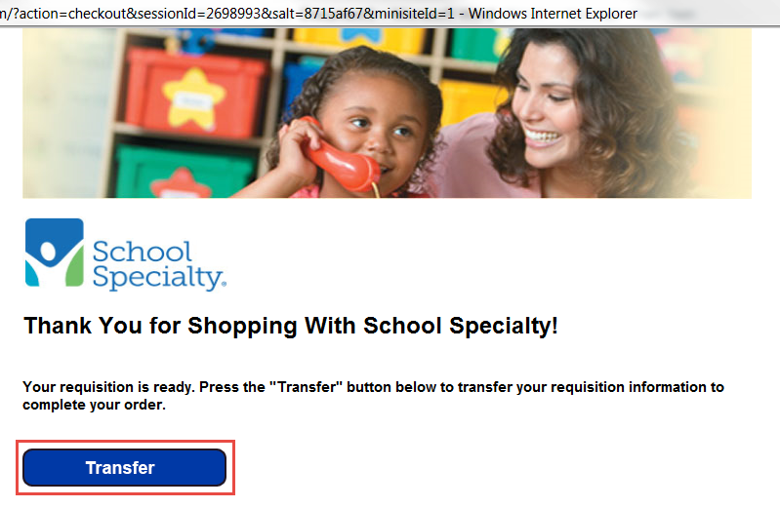

- A PR (Purchase Request) will automatically be created with the items that were selected. The requester should enter the End Use (teacher’s name) and then ‘approve’ the PR (like all other PRs).
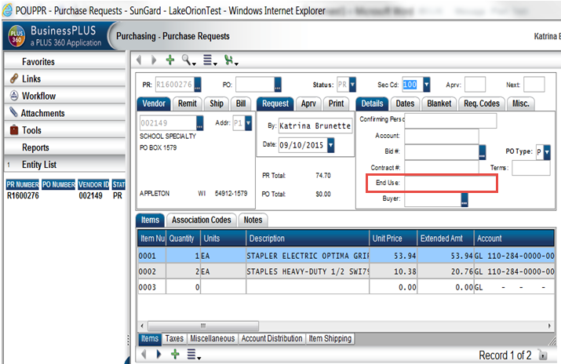
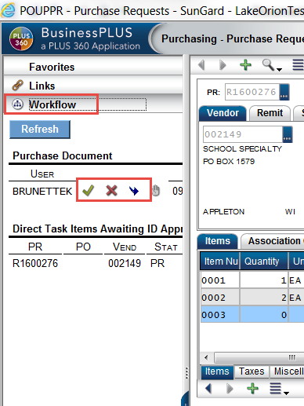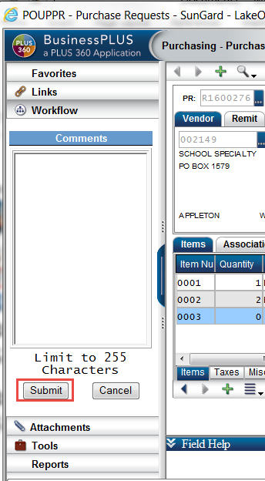

- Once the PR has routed through workflow AND received final approval by Purchasing, the order will be electronically transmitted (not emailed) back to School Specialty for order placement and processing.

- It should be noted that changes to Quantity, Catalog Number, or Unit Price are not allowed for Punch Out purchase requests/orders. The ONLY change that is allowed is to the account number.

